Aalto-yliopisto, Sähkötekniikan korkeakoulu

ELEC-D0301 Protopaja

2017

Loppuraportti

Projekti 11 - Futurice C

Futuwear V2

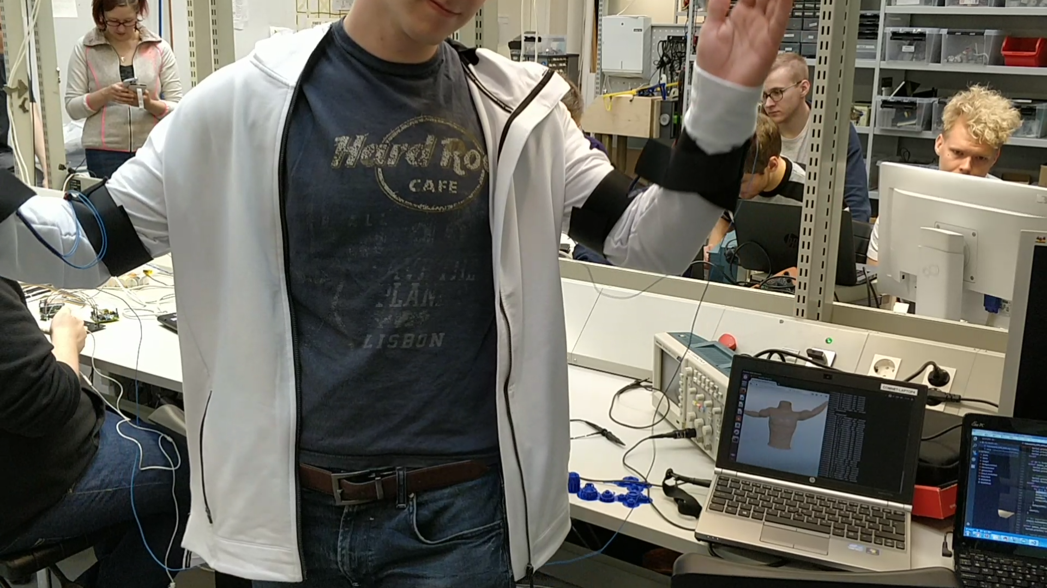

Date: 31.8.2017

Bruce Clayhills

Jere Pylkkänen

Elliot Kölhi

**Information page**

Students

Bruce Clayhills

Jere Pylkkänen

Elliot Kölhi

Project manager

Bruce Clayhills

Sponsoring Company

Futurice Oy

Starting date

5.6.2017

Submitted date

31.8.2017

Date: 31.8.2017

1. **Abstract**

At the beginning of the course, none of the group’s participants really knew, what could be accomplished during the course. From this starting point, we began to design our very first smart clothing, without any real expertise or knowledge of the clothing industry.

Our contact company, which sponsored our project was Futurice Oy. At our very first meeting our contact at Futurice wished us good luck and sent us on to go design the best prototype we could during the summer. We have had a lot of problems and obstacles throughout the course, ranging from sensor problems to design questions and everything in between. However, when we were able to overcome these obstacles, it gave as the determination to create, what we believe to be an impressive prototype.

We started planning in the beginning of June, the smart clothing we would like to produce on the course. Last year a different group had made the first version of the smart clothing, similarly on the Protopaja-course. They gave their prototype the name Futuwear V1, and for that reason, we only deemed it appropriate to call our project revision 2, Futuwear V2. The Futuwear V1 worked with the help of Flex sensors, which measured the movements of the user as well as his/her orientation throughout the period of a workday. They then proceeded to send that information via Bluetooth to a computer and later to a server, which gathered and analyzed the data. Even we got inspiration from the Futuwear V1, we wanted to expand the operating capabilities of the prototype even more.

Together with the group we decided on the MPU-9250 9 DoF (Degrees of Freedom) IMUs (Inertial Measurement Unit), as the main sensors, which measure the users orientation, movements and direction in real-time with improved accuracy over the Futuwear V1. On top of this, our goal was to create an environment and sensory system, which has the capability of contacting the server directly via WiFi, so no computer would have to be used. Now our group was not very experienced, with these sorts of aspects, like clothing, PCB design or even server operation, but with determination and hard work we were able to finish the project with dignity.

All in all we created a smart clothing, which collects data of the user’s movements, processesses that information and sends it to a server for post-processing. This prototype makes it possible to control a 3D-figure remotely, through the internet. There are also numerous application, in which this smart clothing could be utilized. All ranging from remote controlling a robot to mapping the movements of a golf player on the field.

In this report we gathered everything we have done into a single document. Hopefully you, the reader will learn something new from the prototype in which we have invested so many hours. We present, the Futuwear V2.

1. **Tiivistelmä**

Kesäkurssin alkaessa kesäkuussa kukaan ryhmäläisistä ei tarkalleen tiennyt mitä kurssilla voitaisiin oikeasti saada aikaan. Tästä lähdimmekin yhdessä luomaan jokaisen ensimmäistä älyvaatetta, ilman minkäännäköistä tietämystä tai osaamista vaatesuunnittelusta

Sponsoroivana yrityksenämme toimi Futurice Oy, joka samalla toivotti meille onnea ja menestystä, kun kesän alussa lähdimme prototyyppiä suunnittelemaan. Paljon haasteita on kurssin aikana ilmennyt, mutta päästyämme näiden vaikeuksien ylitse, meillä oli kunnianhimoa luoda jotakin erityistä, johon me kaikki pääsimme panostamaan.

Kesän alussa lähdimme suunnittelemaan tarkalleen minkälaisen älyvaatteen haluaisimme luoda. Viime vuonna niin ikään Protopaja-kurssilla oli edellinen ryhmä luonut ensimmäisen version tästä älyvaatteesta, jonka he ristivät nimellä Futuwear V1. Tästä syystä näimme sopivaksi nimetä meidän prototyyppimme nimellä Futuwear V2, joka toivon mukaan luo kunniaa edellisen ryhmän projektillekin. Futuwear V1 toimi flex-antureilla, jotka mittasivat käyttäjän liikkeitä ja asentoa työpäivän aikana, ja Bluetooth antennilla, joka edelleen lähetti dataa eteenpäin tietokoneelle. Vaikka saimmekin inspiraatiota edellisen vuoden prototyypistä, halusimme laajentaa toimintamahdollisuuksia ja vaatteen kykyjä edelleen.

Päädyimme yhdessä ryhmän kanssa käyttämään MPU-9250 9 DoF (Degrees of Freedom) - IMU:ta (Inertial Measurement Unit), jotka mittaavat kehon orientaatiota, suuntaa ja liikettä reaaliaikaisesti paremmalla tarkkuudella, kuin mihin edellinen malli kykeni. Tämän lisäksi tavoitteenamme oli luoda ympäristö ja sensorijärjestelmä, joka kykenee yhdistämään suoraan palvelimelle WiFin välityksellä, niin ettei tietokonetta tarvitsisi enää välikätenä. Meidän ryhmämme ei ollut kovin kokenut tämäntyyppisten asioiden yhteydessä, mutta otimme haaasteen kunnianhimolla ja päättäväisyydellä vastaan.

Loimme siis älyvaatteen, joka kerää dataa käyttäjänsä kehon liikkeistä, käsittelee informaation ja lähettää edelleen palvelimelle jatkokäsiteltäväksi. Tämä prototyyppi mahdollistaa kolmiulotteisten figuurejen ohjaamisen etänä internetin välityksellä. Mahdollisia käyttötarkoituksia prototyppille on monia, niin robotin etäohjauksesta kuin golf-pelaajan liikkeiden mallintamiseen.

Alla on esitetty projektimme kulku vaiheineen. Toivottavasti opitte uutta näette panostuksemme Futuwear V2:seen.

1. **Table of Contents**

**Abstract 3**

**Tiivistelmä 4**

**Introduction** **6**

**Objective** **7**

**PCB** **8**

**Server and WiFi-connection** **15**

**IMUs** **18**

I2C-connection 19

Data processing 19

**Clothing** **21**

**3D Printed enclosures** **23**

**The glove** **25**

**The website** **26**

**The components** **27**

**Reflection of the Project** **30**

Reaching objective 30

Schedule 30

Risk analysis 31

Nearing the end 31

**Discussion and Conclusions** **32**

# Introduction

Smart clothings have been designed and tested for quite some time already. Many companies have tried and created different designs and smart clothings for different applications. Just a handful being the Finnish companies Polar, Suunto and Clothing+. However, even though a lot has been already created and designed, there aren’t many smart clothings with an open source license.

The objective has been to further develop the 2016 Futuwear V1 smart clothing, backed up by Futurice Oy. The last year’s prototype was created to measure the work ergonomics of the user during a course of a day. The data was sent to a computer over Bluetooth, which then sent it further on to a server. In this year’s (2017) version we wanted to be able to map the movements of a user’s body and send that positional information directly to a server via WiFi, eliminating the need for a third party computer. With passion and determination we took the project, in order to create something unique and memorable for all of us. Maybe one day this technology could be used to control different figures, from 3D-models in a VR-game to real life robots remotely from the other side of the globe. Hopefully you’ll appreciate what we have accomplished during the course, and see the effort we put into the design itself. The Futuwear V2.

# Objective

The client’s goal for the team is to continue the development of the 2016 Futuwear V1 open source smart clothing. This version will be able to map the movements of the user in great detail and precision. After a successful prototype, we’ll evaluate the possibility to map the movements of the fingers and legs.

With the help of the smart clothing, positional information is sent directly to the server via WiFi. After sending and receiving the data, it can be viewed through a web-interface. The connection must be secure. If no there is no existing program to merge the movements of the user to an interface, one must be created during the course of the project. The concept will be presented in a demo-liveshow. The user’s movements, who is wearing the garment, will be shown to the public with the help of a monitor.

The team has set the following goals for a successed project:

The open source concept of the project is innovative and brings additional value to the sponsoring company. With the available 900 euros the team will design and build the most user friendly, cost-effective, operating, reliable and easy solution possible. The prototypes different components, ie. the processor, sensors, power supply, protective case and so on will be seamlessly integrated into the esthetics of the clothing itself. Also the textiles are going to be ergonomic, light, and durable. The power supply will be sufficient enough of that the user can use the smart clothing for 8 hours straight.

# PCB

* 1. **Schematic design:**

The schematic of the PCB (or Printed Circuit Board) was made in KiCad (more specifically with Eeschema). An open source program, that allows users to create custom PCB designs and schematics. The schematic has a lot of different components, but the main parts comprise of the MCU (Microcontroller unit), battery protection circuit, LDO (low-dropout regulator), USB to serial converter and the LiPo battery. Every aspect of the schematic was designed, in mind that the main power source would be a LiPo battery. The components support this battery type and the board is stable only when the LiPo is connected.

The MCU was the ESP32 WROOM module from Espressif. The module itself had all the required components to run the microprocessor, including the oscillator and pull-ups etc. Although some space was sacrificed on the PCB itself, because the module was used, it also made it easier to solder on. We also didn’t have to go through every detail of the module’s datasheet to learn how to configure it, and this saved us a lot of time. The module also has a built-in WiFi antenna, which was ideal for our use cases.

The ESP32 supports I2C as well as SPI for communication with external sensors. It also has 20 GPIO pins for connecting multiple IoT sensors. The ESP32 requires a supply voltage of 3.3V and draws a maximum of 250 uA. The CPU (Central Processor Unit) of the ESP32 is an Xtensa Single-/Dual-core 32-bit LX6 microprocessor and it has 520kB of internal SRAM.

The LDO (or low-dropout regulator) is a device, that drops the voltage of the LiPo battery to the 3.3V required by the main circuit (the MCU and USB to serial converter). It offers low voltage drops and excellent efficiency so that we can extend the operating time of the board with the LiPo pack.

The battery protection circuit (BQ29733DSER) ensures that the voltage of the LiPo battery doesn't fall below the dangerous 3.0V LiPo limit, after which one cell LiPo batteries tend to be irreversibly damaged. The battery protection circuit also prevents the N-channel MOSFETs from delivering current to the board during a fault in one of the components or a short circuit on the board.

The charger (MCP73831) makes it possible to charge the LiPo battery via the USB port, while it's connected to the board. The circuit easily handles 5.0V, so it can be charged and powered from a computer's USB hub. The MCP73831 is a programmable charger, which delivers 500mA to the battery pack. The charger communicates with the BQ29733DSER, so that it knows when the battery is being charged and activates the MOSFETs to allow current flow. The charger also has a status indicator LED, which lights up when the battery is charged to its maximum.

The USB to Serial converter (CP2102-GM) makes it possible to program the ESP32 WROOM module. The converter also sends out an indication voltage, which lets the computer know that a successful USB connection has been established with the slave device.

The GPIO pins are connected to pin headers in the schematic. This way they can be easily connected to external sensors from the board and the sensors can be powered on via the PCB itself. This eliminates the need for an external power source for all of the sensors inside the clothing.

The circuit is designed to use I2C, as the sensors seemed to function better with I2C over SPI. We tested many pull-up resistors, while we used the ESP32 Thing. The schematic now has two pull-up resistors connected to the SDA and SCL lines of the MCU. These resistors are there to make sure the clock lines work with precision and also reliably. However no pull-up resistors have been connected to the GPIO pins, as this was not mandatory for the optimal performance of the PCB, with the application the pins had in our prototype.

All the connections were checked with ERC (Electrical Rules Check) before starting the PCB layout design. KiCad showed no errors in the design and let the design through to the next phase. There were however two small errors with the schematic design. Two pins weren’t connected to ground and one pull-up resistor needed to be added on one of the pins. These design errors have however been corrected in the updated KiCad schematic file.

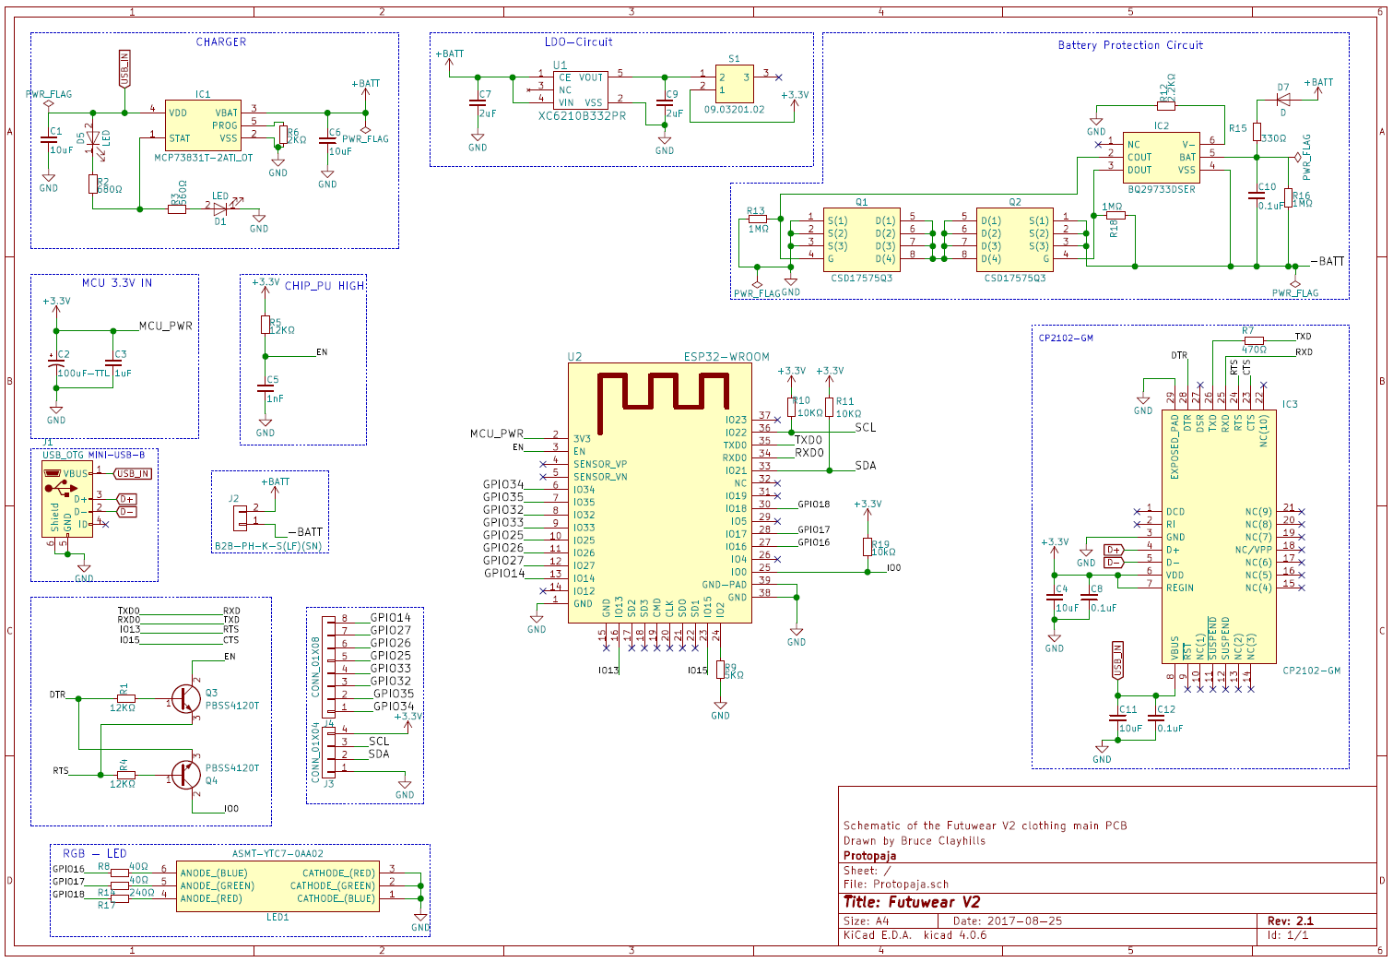

Figure 1. The Futuwear V2 schematic

* 1. **PCB layout**

The PCB design was made in the PcbNew-software, which is a part of KiCad. A lot of time went into learning how to use the PCB software. Two different PCB layouts were made. The initial design was shot down by our assistant, due to the bad placement of the WiFi antenna and the size of the PCB itself. After learning how to use the software even better, the second iteration of the design went through with our assistant.

In the initial design, the ESP32 was located, so that the WiFi antenna was lying on the ground fill zone of the PCB. This evidently would have interfered with the 2.4GHz WiFi communication and the PCB had to be redesigned, so that the antenna would stick out of the end of the PCB. The components were also far to spread out in the initial design, and they had to be rearranged, to make the board’s dimensions smaller (The final dimensions ended up being 61x50mm).

The idea from the beginning was to order the PCB from a manufacturer. This allowed us to use very small components on the PCB. The quality of the PCB from a manufacturer is also much better than what could’ve been achieved with the tools we had at the workshop.

Attention to detail was also one aspect that was kept in mind during the development of the PCB. Little things like rounded edges and neat traces, ensured that the final PCB looks professional and tidy. The GPIO pins were drawn to the sides of the board for easy access. Voltage, ground, SDA and SCL lines were drawn to the left of the board, while the GPIO pins were drawn to the right side. This made it easier for the end user, or us, to distinguish between the lines. Less room for error this way, when there is no fear of connecting the pins the wrong way around.

However there were slight mistakes with the PCB design. All of the footprints for the components, were downloaded from the internet, except for the most common ones (capacitors, resistors, etc.). This also saved us time, because the footprints didn’t have to be made individually . However the PCB was in such a rush, that a slight error was overlooked. One of the component footprints (BQ29733DSER) had two of the pins in the wrong places. This was fixed however during the assembly of the PCB.

It was easy to learn how to use KiCad, as the internet offers well documented tutorials and videos, that one can watch. The PCB has two ground pours, one on the top and another on the bottom. This way it’s easier to connect a lot of the components, because most of them require some connection to ground in the circuit. The PCB is in this way two-sided. This was cheaper to manufacture and the prototype didn’t need to be small, so a multilayer design was pointless at this stage.

The top layer of the PCB can be seen by the red color on Figure 2. and the bottom as green. The placement of the mini USB port to the upper right corner, made easy access to programming the board possible. The LiPo connector placement also made it possible to put the whole package (PCB and the LiPo) into a 3D printed case.

If desired, the user could solder on pin headers onto the GPIO pins and to the voltage and IC2 lines. This way it could be easier to connect sensors fast and reliably. The switch on the board, which connects the main circuit, is made out of a 3 pin pin-header. Our intention for the final prototype was to mount the switch directly to the board, but with the use of an ordinary 3-pin header, it is possible to route the wires to a specified location and install a switch there for easier use of the power switch.

Otherwise we are fairly pleased with the outcome of the PCB. Of course it has its faults and errors, but it works fine after everything was fixed.

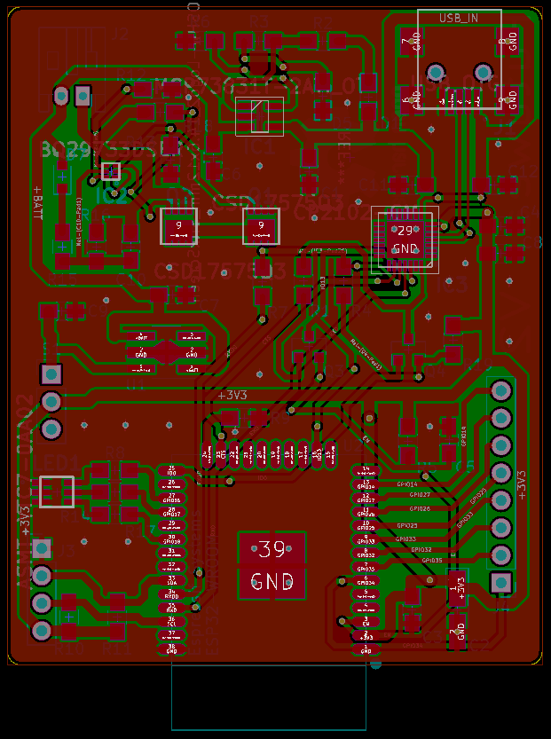

Figure 2. PCB layout

* 1. **Assembly of the PCB**

The assembly of the PCB had its own difficulties too. No one in our group had ever soldered on SMD components before, let alone so small parts that we had. But the finished board ended up being pretty good.

The assembly of the PCB took place during two consecutive days. After day one all of the main components were soldered on, and only the resistors and capacitors remained. The faults in the schematic design and the PCB design stages had to be corrected too.

The battery protection circuit (BQ29733DSER) had the two pins going the wrong way on the board. The solder mask and the copper trace had to be manually scraped off by hand, from both pins with the help of a microscope and steady hands. After that, a jumper cable had to be attached from one pin to the other, to establish and fix the broken connection. The other connection was soldered on straight to the trace of the other pin (so no cable required there). It may look atrocious, but it gets the job done.

The next day the rest of the components were soldered on the PCB and the PCB was powered on for the very first time.

And success!

Not quite. The first time the power was connected to the board via a mini USB cable, nothing happened. The board had to be then troubleshooted for any design errors or flaws on the PCB. After going through every part of the PCB in detail the problem was found. One of the pins on the mini USB port wasn’t connected properly. In fact it was the VCC pin, that wasn’t supplying voltage to the board. The USB port was then resoldered onto the board and the board was tested another time.

This time one of the LEDs lit up on the board, but the computer refused to recognize it (well it recognized it for a second and then the board immediately shut down). The PCB still had one error, but it couldn’t be found. The next day one of our assistants, Juha looked at the board. After going through it with a microscope he noticed that one of the connections, that were cut off, were in fact still connected. This resulted in a short circuit, and the battery protection circuit cut off the power, when current was passed on to the main components (MCU and USB to serial converter). The appropriate connections were cut off and the board was reconnected to a computer to check the connection.

The computer recognized the USB-to serial converter and the board was connected without any problems. The board was now functioning and the battery charger worked fine as well. It charged the battery from 3.7V to over 4.1V correctly via the USB port. After the board was functioning it was time to try to communicate to it for the very first time.

One other shortcoming, though not a deal breaker, was with the circuit itself too. The PCBs circuit is not stable enough to function without a LiPo battery. Or in other words, the charger component doesn’t supply adequate current to all of the components, to power it only through the mini USB port on the board. The board then requires the LiPo battery pack to function nominally. However, the board is designed to be an IoT device and not a microcontroller, so a LiPo pack would be needed for the application anyway.

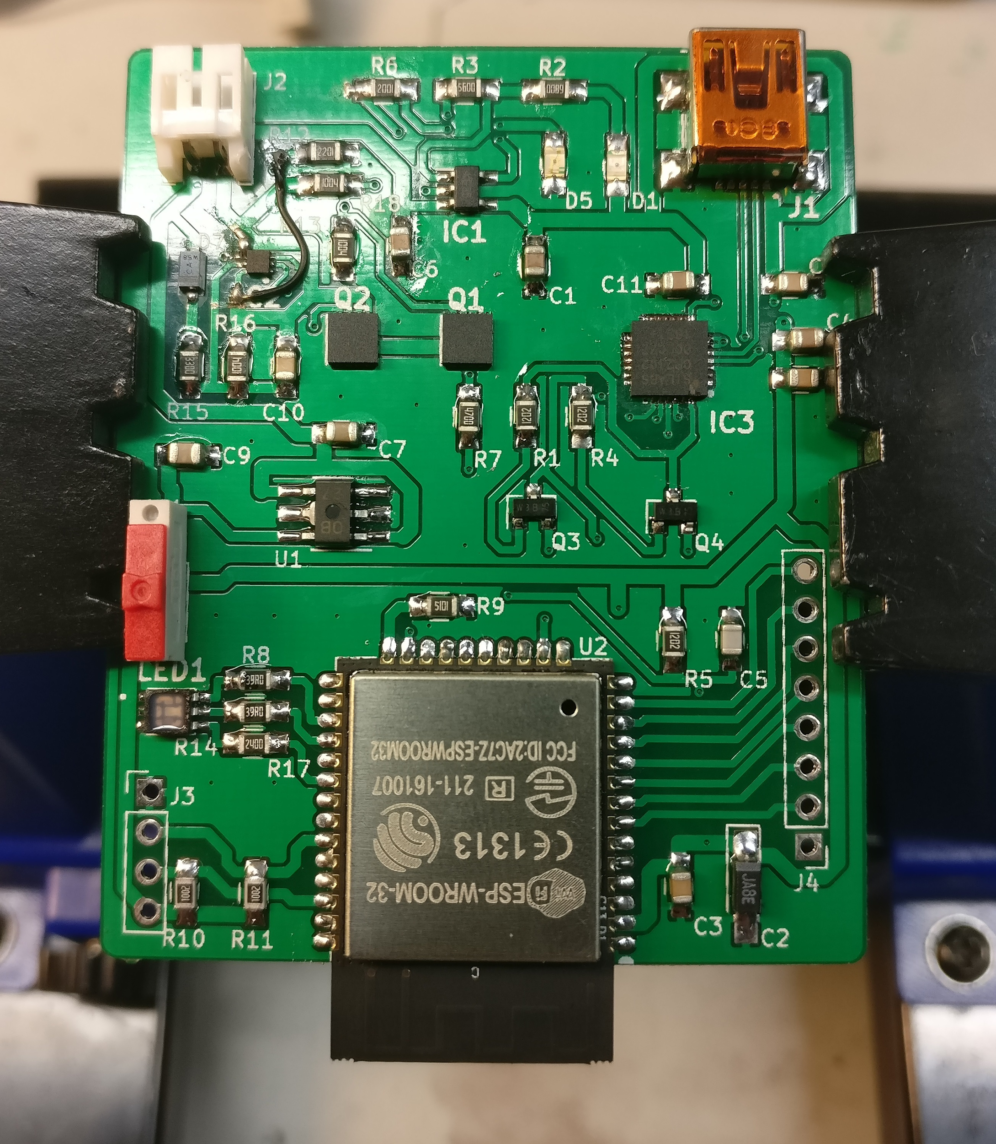

Figure 3. The constructed PCB

The red switch in Figure 3. is the power switch for the main circuit (the WROOM module found at the bottom of the photo and the USB to Serial converter, denoted by the IC3 label). The LiPo battery can be connected to the PCB at all times and the board can be powered on through this switch, which allows current to flow in the circuit. This makes it possible to turn off the board, without disconnecting the LiPo battery.

While the components were being chosen for the end prototype, there was one work-around that had to be done. The battery protection circuit (BQ29733DSER) has a battery voltage input, which reads the voltage of the battery, and disconnects the power accordingly. However the disconnection voltage had been set to 2.8V, which is far too low for the LiPo battery, as it would be permanently damaged, if the voltage would drop to such low values. This problem was overcome by setting a voltage dropping diode in between the BQ29733DSER and the LiPo’s positive terminal. In order for the diode to drop the voltage, current had to flow as well. This in mind, a 1MΩ resistor was connected in series with the diode. Although current will flow, even when the main circuit is disconnected and the battery is connected, this probably will not damage the battery. This is due to the fact, that according to our calculations, the 2000mAh battery would deplete to dangerous voltage levels in 67 years. It is highly unlikely that a LiPo battery would even survive this long.

Every resistor, capacitor and diode used on this board are 0805 size SMD components. If desired the board could be made significantly smaller in size, with the use of smaller parts. However the dimensions of the LiPo battery are approximately 44x60mm, so for this form factor we wouldn’t even need a smaller board. Due to the fact that the PCB design aspect of the project was a totally new area, the board was made with the ideology, that it would be suitable for beginners. Of course future iterations of the prototype could be much smaller, if it would be manufactured by a manufacturer. However once again because of the LiPo pack and, as this was a prototype, the need for a very small form factor for the PCB wasn’t relevant.

# Server and WiFi-connection

* 1. **ESP32 WiFi**

The ESP32 microcontroller has built-in WiFi-connectivity, so a separate WiFi-module was not needed. The WiFi-library used was the one provided as a part of the ESP32 Arduino core. The device connects to a WiFi network, whose SSID and password have been hardcoded into the source code. The device could be programmed to scan for WiFi networks, but since there is no input method to enter a password, it wouldn’t be very useful. Since the ESP32 also supports Bluetooth, it would be possible to for example create a smartphone application that allows the user to select which WiFi network is used and input the password.

The IMU data is sent to the server as UDP packets containing 20 bytes of information. With 20 bytes added from the IPv4 header and 8 bytes from the UDP header, the total size of each packet is 48 bytes. Therefore the device requires very low bandwidth from the WiFi connection, only around 4.7 KiB/s at 100 Hz update rate. Latency didn’t seem to be noticeable to the naked eye, even though fast response time is crucial for a device that is supposed to provide real-time response to user input.

The 20 byte package size consists of 4 bytes per IMU. Those 4 bytes contain the pitch, roll and yaw angles for the IMU, all as integers ranging from 0 to 1624, making the accuracy around fourth of a degree. Each value has its own digit in base 1625, so the first 2 values are multiplied by 1625² and 1625 respectively. Similar result could’ve been achieved more efficiently by simply allotting 10 bits per value, resulting in values from 0 to 1023 for each angle and allowing the use of bit shifting instead of multiplication and division. However, CPU time was not considered a bottleneck either for the ESP32 or the server, thus slightly increased accuracy was chosen over fewer floating point operations.

The device checks if it should send data every 10 ms, so it operates at an effective update rate of 100 Hz. However, if none of the angles have changed more than around 1 degree since the previous message, the device will not send any data to the server. This is done mainly to increase battery life, since as mentioned earlier, the bandwidth used by the device is miniscule at fewer than 5 KiB/s.

There is no sort of protection for the UDP connection. Any device could send bogus data to the server, and it would try to process that data as if it came from the shirt. This could be fixed by expanding the web interface to have options to whitelist a shirt and block other connections. There is also no identification process for the shirt, meaning that the current implementation only supports a single shirt. A scalable solution would be to have the shirt first connect to a server that gives it an unique ID and a new UDP server to connect to. The shirt would then start all its messages with the ID it was given.

WebSocket connection between the ESP32 and the server was originally tested before UDP, but it didn’t provide the needed responsiveness. The WebSocket connection would get seemingly congested after sending data for a while, then further attempts to write more data would take seconds to complete for a while. Various possible solutions were tried out, such as using TCP-protocol’s NoDelay option, trying to find out some sort of buffer setting that could be disabled on either on the ESP32 or the server, sending the whole packet with a single WiFi-client write call in case it was immediately sending even single bytes at a time with huge overhead from TCP/IP, and explicitly flushing the WiFi-client to make sure that the data is sent.

The only way to keep the WebSocket connection stable with no unexpected pauses was to set the message sent rate extremely low (around 4 Hz). This was obviously unacceptable, so UDP was chosen instead.

* 1. **Server**

The server uses Node.JS to host 3 different types of services on 3 ports. There’s HTTP server to host the static files for the web-interface, UDP server to handle data from the shirt, and a WebSocket server to send the real-time IMU-data to the web-interface. All of these are started by running the run.js file in the Server folder in the GitHub directory.

The server processes the data received from the ESP32, and sends it forward through the WebSocket in a more programmer friendly form. The data is sent as JSON packets that include the keys “bone_name”, “X”, “Y” and “Z”. The X, Y and Z values are roll, pitch and yaw angles converted to degrees. Any application could establish a WebSocket connection to the server, and receive this data. Every time the server receives data from the device, it broadcasts the WebSocket messages to every WebSocket client that has established a connection with it.

|  |  |
| --- | --- |
| bone_name | “L_Arm_Inner” |
| X | 74.53 |
| Y | -23.34 |
| Z | 0 |

Table 1. Example contents of a JSON-packet sent to the web-interface

The server occasionally pings all open WebSocket connections, since they would otherwise eventually close, if no data is received from the shirt. The server only support one shirt, and would require various changes to support more.

To test the server before the UDP connection from the ESP32 was working, data was sent to a computer through Serial connection and that data was forwarded to the server through a WebSocket connection. The files for this test are included in the GitHub directory under “Arduino/Testing/FutuwearV2_Serial”.

* 1. **Web-interface**

The web-interface is extremely simple. It automatically opens a WebSocket connection between the browser and the server, and it displays the data on a 3D model of a torso. The torso was inherited from Protopaja 2016’s Futuwear group, but various changes were made to the back-end to make it work better with the IMU data. Limits to which angles the bones could rotate to were removed, and instead of the torso.js receiving raw sensor data, it now receives angles. The code was also cleaned up in other ways, such as replacing long switch cases with a more object-oriented approach.

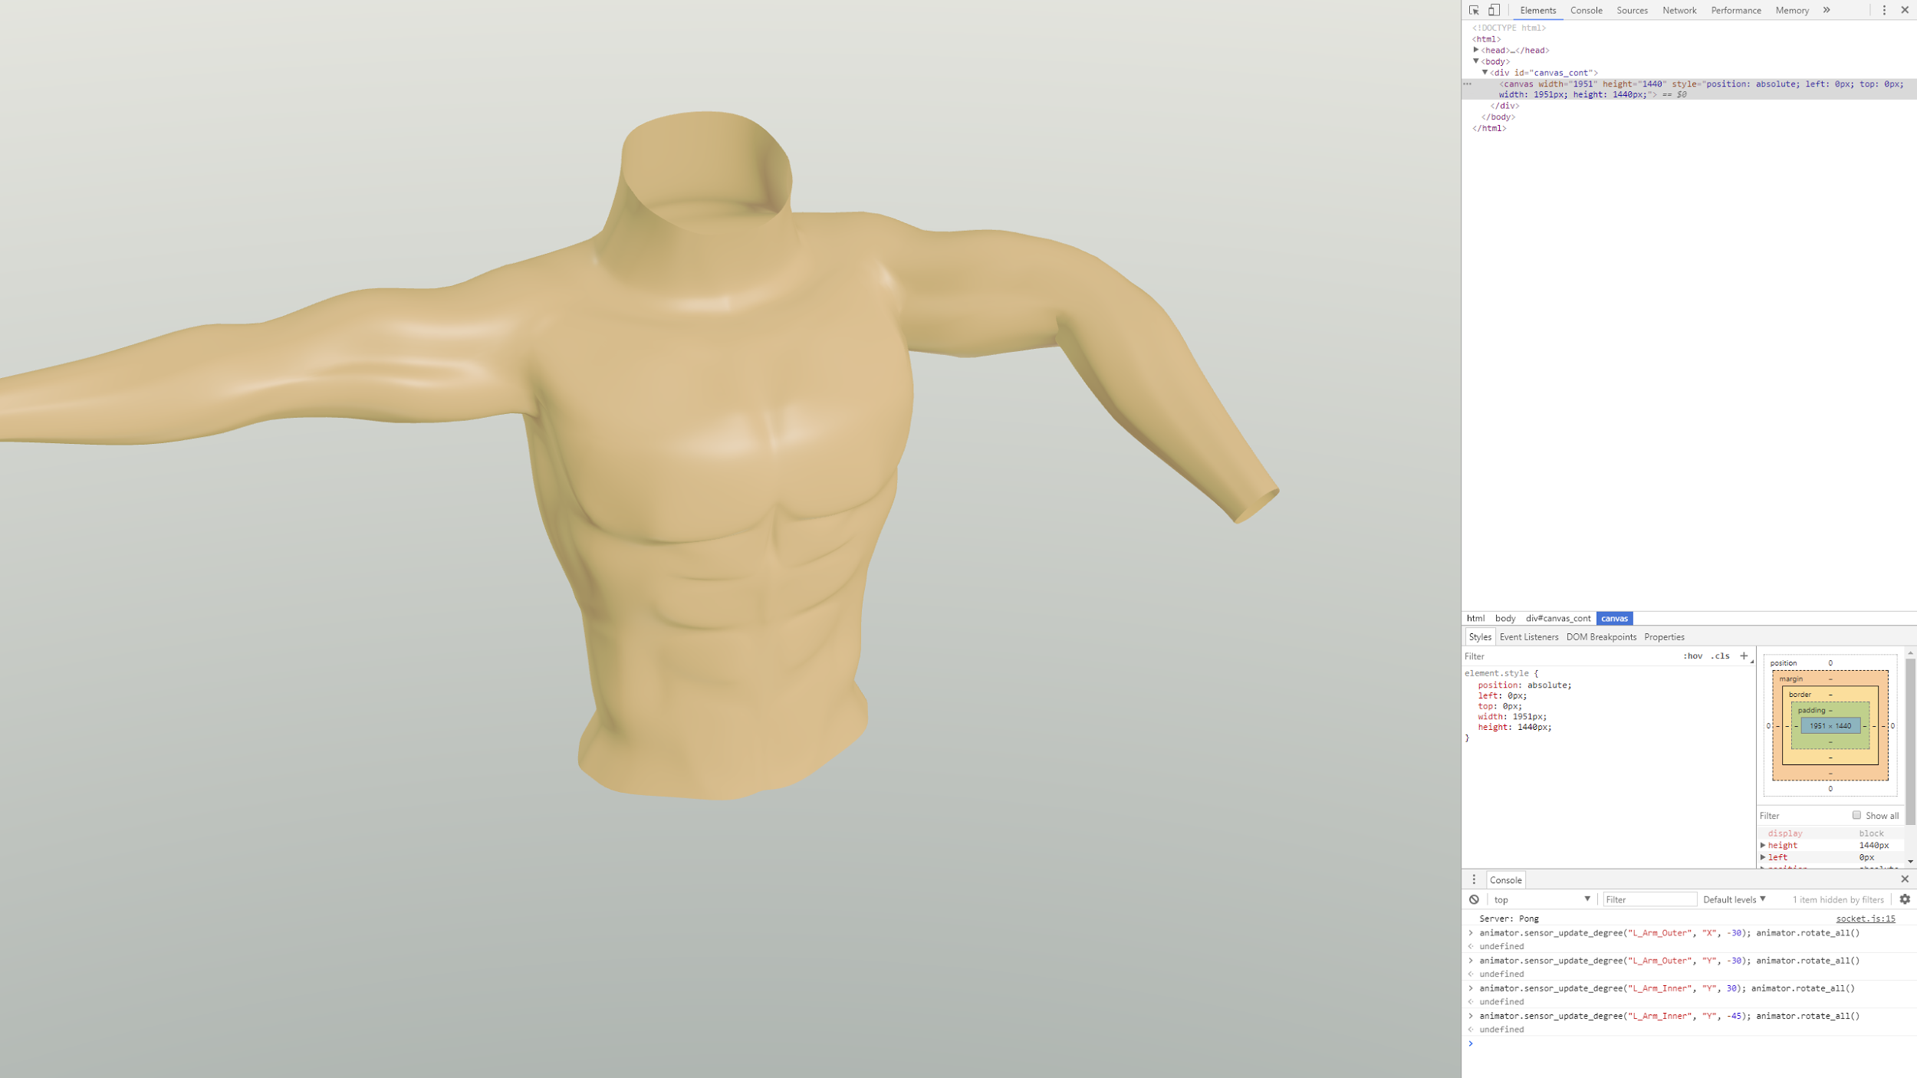

Figure 4. Torso model shown in the web-interface

# IMUs

The IMUs (inertial measurement units) used in the project are MPU-9250s. More specifically, SparkFun’s MPU-9250 IMU BreakOut boards. The MPU-9250 is a 9 DoF (degrees of freedom) IMU, which means that it has a 3 axis accelerometer, 3 axis gyroscope, and a 3 axis magnetometer. The accelerometer and the gyroscope are included in a MPU-6500 6 DoF IMU and the magnetometer is AK8963. Both of these are included in the MPU-9250.

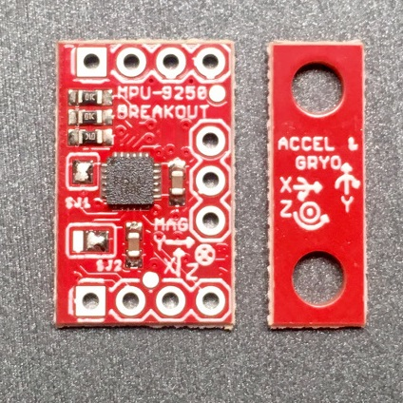

Figure 5. MPU-9250 breakout board

Data from all of these sensors is combined to get accurate data about the 3D orientation of the IMU. 5 of these IMUs are placed in the shirt, 2 on each arm and 1 on the back. The IMU on the back is used as a basis for the other 4 IMUs, and the 2 IMUs on the arms are placed near the wrist and above the elbow so that they track the 2 main bones in the arms. Since most of the movement of the arms is based around the movement of these 2 bones, no more IMUs were deemed necessary.

The physical size of the breakout board is small enough that, that we could utilize them directly. 3D-printed cases, were small enough to hide inside the cloth and the breakout boards were easy to solder on.

## I2C-connection

The IMUs communicate with the MCU through an I2C connection. The MPU-9250 can only switch between two I2C-addresses, so all 5 IMUs could not have their own unique address. However, it was possible to connect all 5 IMUs without an I2C multiplexer by dynamically changing the addresses. The MPU-9250’s I2C address is changed by changing the logic value of the A0-pin, 0x68 when it’s low and 0x69 when it’s high. Each IMU has its dedicated GPIO-port, which is connected to the A0-pin. When idle, the value of all A0-pins is set to high, setting them all to the 0x69 address. When the MCU gets data from one of the IMUs, it sets the A0-pin low, changing the address of only that one IMU to 0x68. After the data is read from the IMU, the A0-pin is set back to high. This way 0x68 is the only I2C-address the MCU reads accelerometer and gyroscope data from.

The AK8963 magnetometer only has one static I2C address, but it can be disabled programmatically by changing the value of one of the MPU-6500’s registers. There is very little delay associated with this mode switch (less than 100 µs), so even though it needs to be done once per IMU per read cycle, no meaningful delay is caused with fewer than 10 IMUs.

Since the I2C connection requires address switching and mode switching, the SPI-connection also supported by the MCU and the IMU was tested as well. However, for an unknown reason the IMU would stop sending data after a short while in SPI-mode. After going back to using the I2C-connection, it was speculated that the issues with the SPI mode could’ve been caused by the magnetometers, which were still using I2C to communicate with the MPU-6500, which forwarded the data through the SPI connection. Since the MPU-9250 uses mostly the same pins in SPI mode as it does in I2C mode, this could’ve potentially caused some issues. This issue wasn’t resolved, since the I2C mode worked just fine in the end, and it was deemed unnecessary to invest more time into the SPI connection.

## Data processing

The data received from the IMU is processed by the MCU, because for accurate results the orientation of the object needs to be constantly updated. If the raw data was sent over the WiFi and the server processed the data, possible lost packets and delays would make the calculated result inaccurate. In addition, since the WiFi-connection is the main power drawer of the device, reducing the amount of data sent is more important than reducing the amount of processing done by the MCU. The ESP32 is a very powerful MCU at 240 MHz clock speed, so it can handle the data processing quite well.

Processing the data on the MCU allowed sending smaller packets. For each IMU there are 3 processed data points, which fit in 4 bytes when reduced to a still reasonable accuracy of around fourth of a degree for each axis, whereas there are 9 raw data points. Additionally, a timestamp would’ve had to be sent with the raw data, since that is needed to calculate the delay between when two packets were measured, since the latency of the WiFi-connection is not constant.

The Mahony filter was used in the fusion algorithm, which combines the data from the different sensors. The algorithm does not calculate change of orientation perpendicular to the axis of gravity, which is an issue that should’ve been solved. Data from the magnetometer and the gyroscope could be used to calculate this, but due to a lack of time and personnel this was not achieved. This issue means that the shirt can recognize when the hand is moved up and down, but not when it is moved from front to back.

Most of the Arduino software libraries available for the MPU-9250 are incomplete in various ways. For example, the SPI support for all of the tested libraries was very poor, so when the SPI connection was tested, large changes to the used library were needed. To figure out the right registry values to for example enable or disable the I2C bypass mode to connect or disconnect the magnetometer, the MPU-9250 register map needed to be referenced.

The MPU-9250 library that was eventually used was provided by SparkFun, the manufacturer of the breakout board. The library originally only supported one IMU at a time, since it saved some values as global variables. To support the 5 IMU connection that was used, the MPU9250 and the fusion algorithm were turned into objects that hold their own data. Also, since the A0-pin on the MPU-9250 was used to dynamically change the address of the current IMU during the read cycle, that had to be facilitated in the library. Similarly to how the SPI-library had a select and deselect functions to enable and disable the chip-select pin, the same functions were repurposed to enable or disable the A0-pin.

There were a couple of different methods to calibrate the magnetometer, and the different methods resulted in different type of data. The method that was used in the end took data points while the IMU was rotated to find minimum and maximum values for the axes, then calculated biases based on the results. Other possible solutions, such as the MotionCal[1] software were explored, but the method used was deemed to be the simplest, while still working well enough.

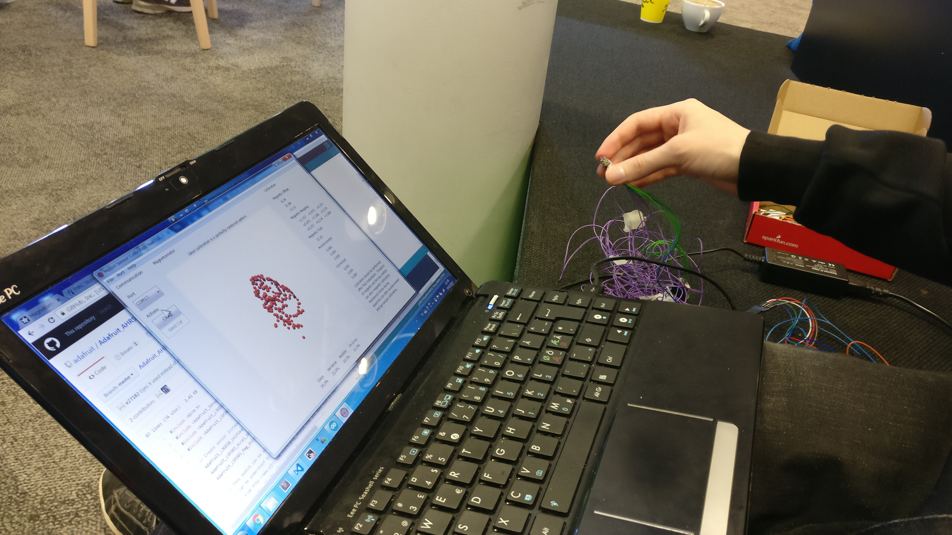

Figure 6. MotionCal IMU calibration software

# Clothing

* 1. Design

-

The plan for the clothing base was to create a modular system that would connect the MCU to the desired number of IMUs as well as possibly other expansion modules. It was also intended that it should also be able to be used as a normal piece of clothing and to be machine washable if all the hardware was removed. As we were somewhat short on time we decided to use a pre-existing piece of clothing that would serve as the base. The connections would be routed by sewing conductive thread into the fabric and the MCU and IMUs would be housed in separate pouches that would be attached via snap buttons and secured with Velcro. There would also be an internal backing material that the conductive thread would be sewn into to minimize it’s exposure and ideally make the piece look more aesthetically pleasing, this backing material was a stretchy polyester that was chosen so as not to impede the flexibility of the user.

* 1. Implementation

The construction of the pouches/straps that housed the MCU and IMUs went quickly and without significant difficulties. Comprising of a rectangle of neoprene with some reinforced stretchy polyester sew on to act as the pouch and some Velcro pieces of attachment it was a very simple task to perform with a sewing machine. Attaching the snap buttons to both the pouches and the clothing was also easy but tedious and time consuming.

Initially sewing on the backing material posed more of a challenge and required splitting open the seams of the sleeves of the jacket that was being used to properly access all the desired areas.

Once this was done the backing material was attached with a simple stitch to secure it until it was to be attached more properly with another layer of backing material for additional protection.

Sewing the conductive thread proved both challenging and time consuming as the conductive thread had no stretch to it and had a tendency to come undone when tied in knots. The lack of stretch meant that when sewn into the stretchy backing material, if it was too tight it would snap of come undone under stress and if made longer to compensate would cross over with neighboring threads and cause a short. The pattern of the connections also required the threads to split in multiple locations, and the only way to make branching connections was to tie two pieces together with knots, which as already mentioned had a tendency to come undone.

Though this initial design did work very briefly the issues eventually became too much of a hassle to work around and the group decided to scrap this design in favor of a more traditional one using solid core wire.

* 1. The revised design

As the threads, had proven to be extremely unreliable, all the conductive thread was stripped from the jacket. Initially the replacement was to use smaller pieces of conductive thread to tie long piece of wire to the snap buttons and connect everything that way. This method proved too tedious and time consuming and as the group only had at most 12 hours to finish the project we made the decision to solder the wire directly to the snap buttons.

This setup worked more reliably than most previous setups, though it still had many issues, mostly stemming from the weak snap buttons that had a tendency of disconnecting if not secured properly.

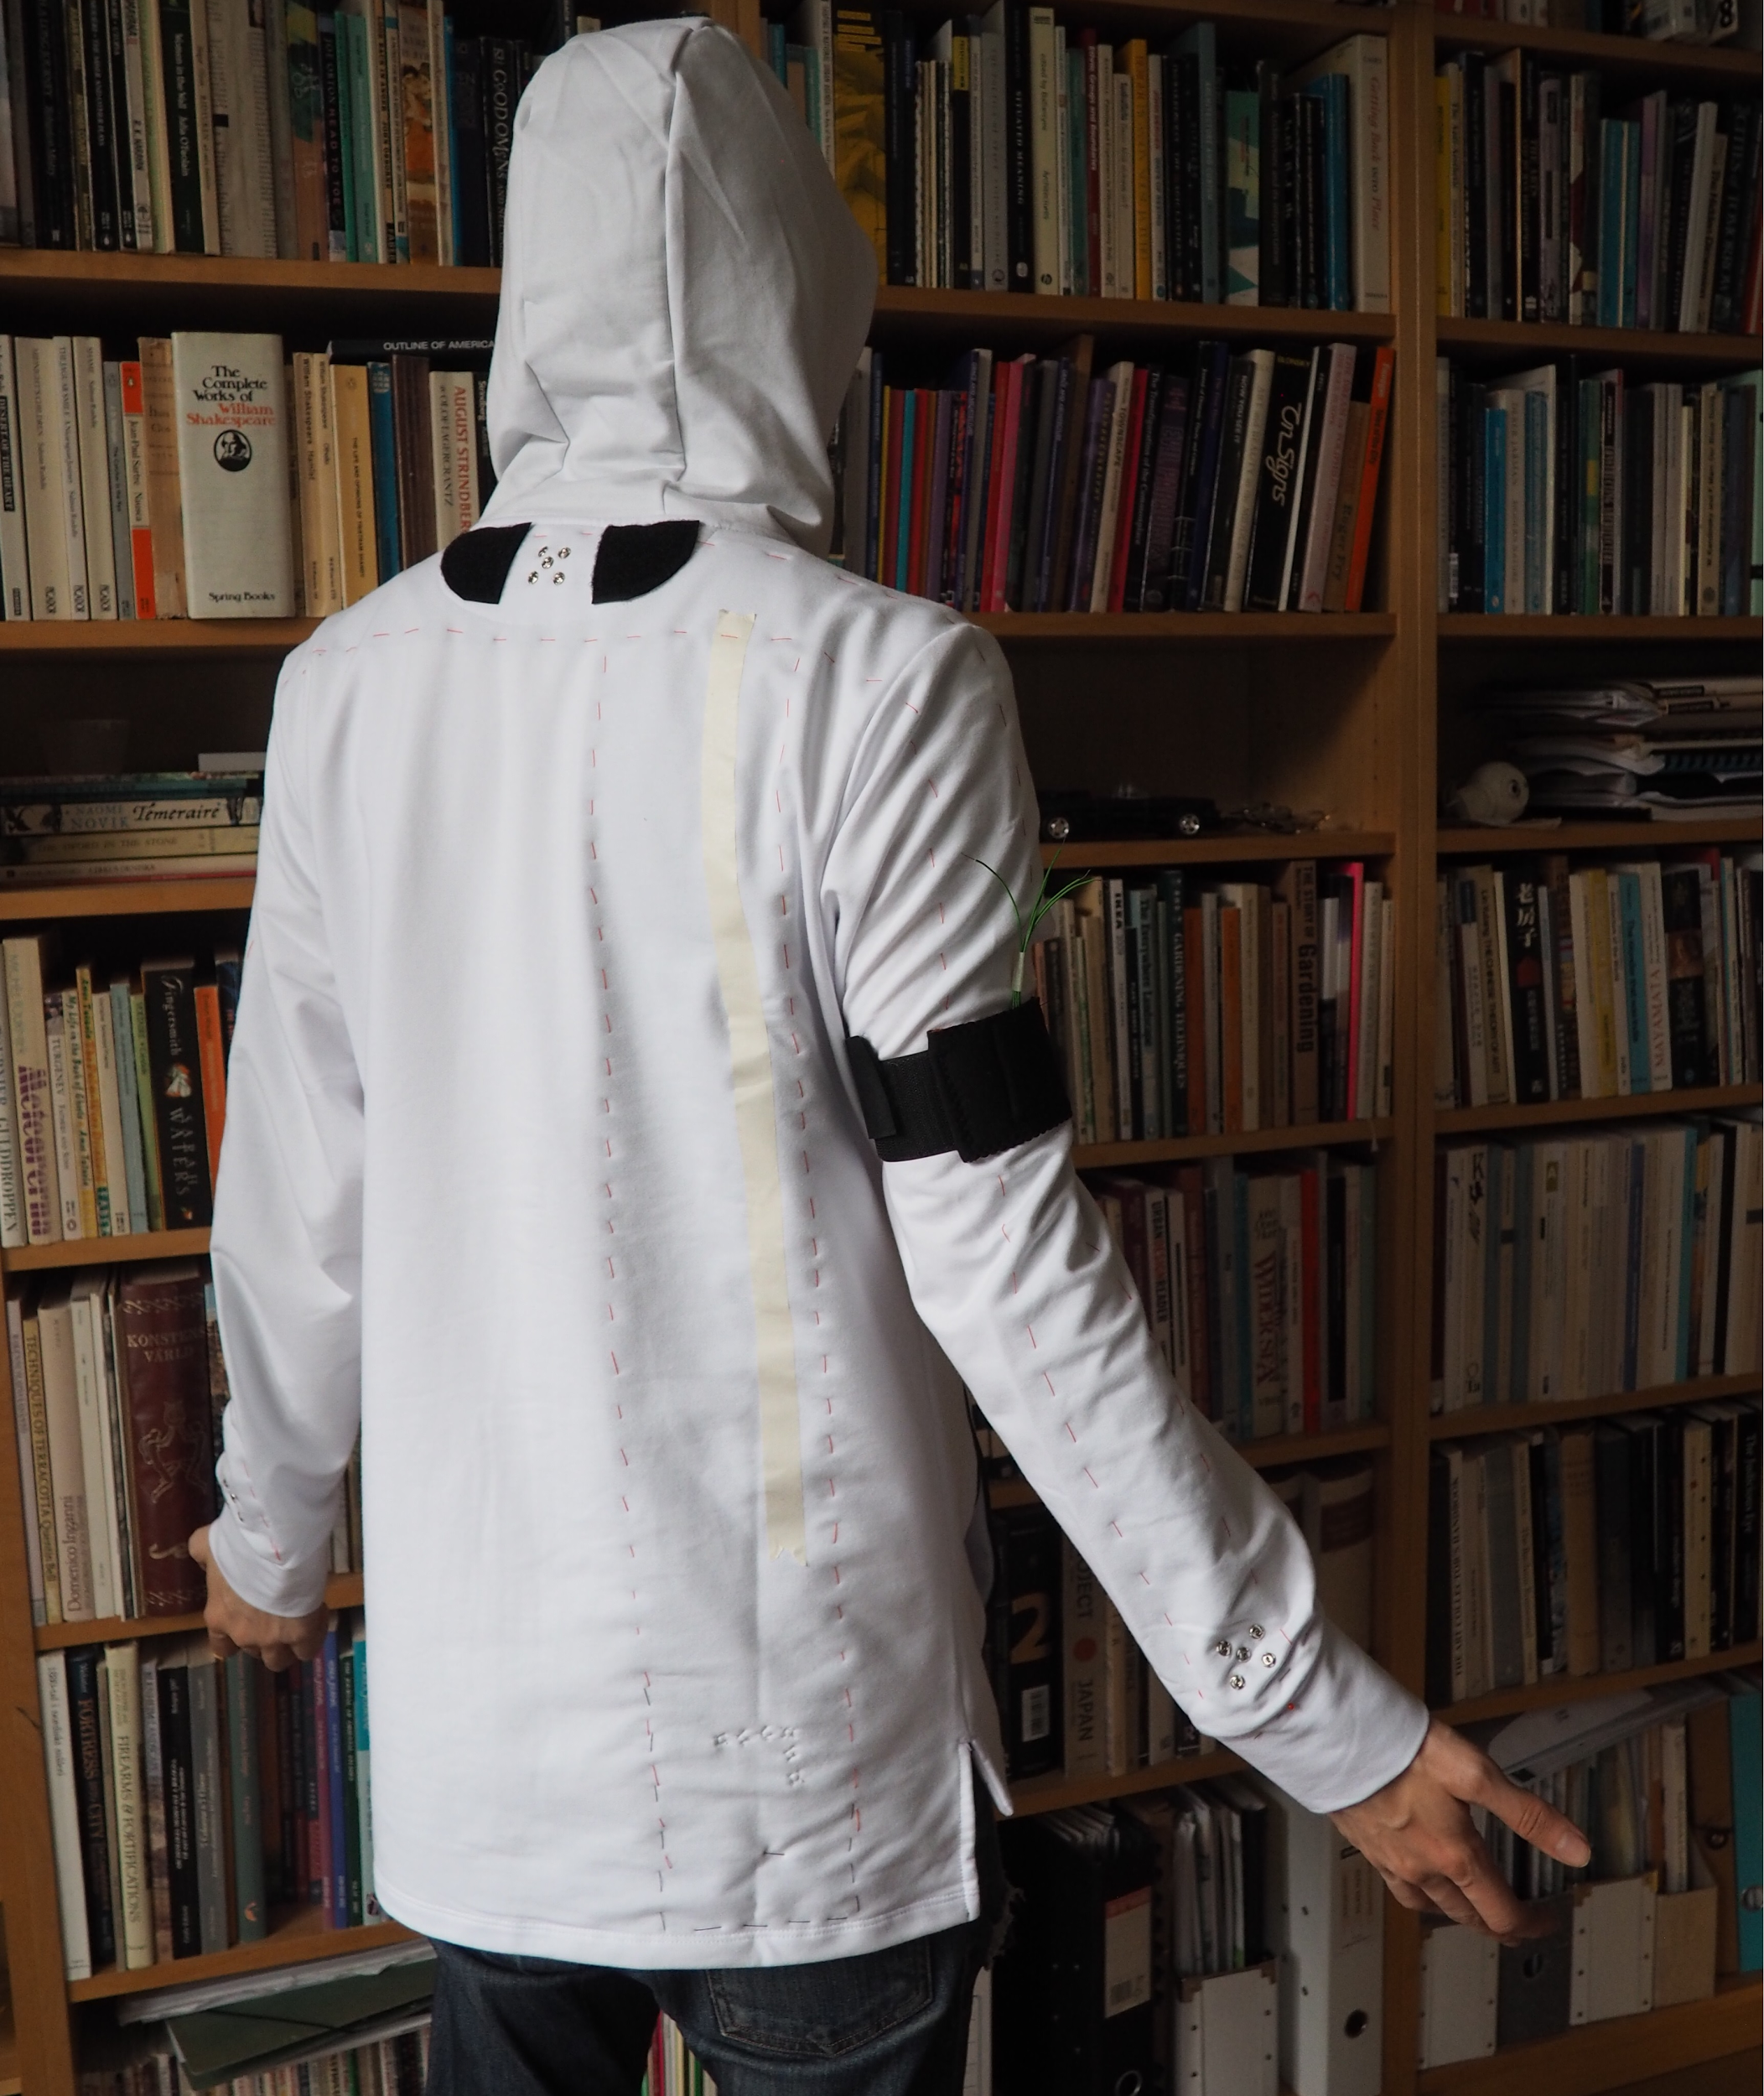

Figure 7. The shirt with an IMU strap connected to the upper right arm, and the connector points showing in back and the lower right arm.

# 3D Printed enclosures

* 1. Design

The design of the 3D printed enclosures for the MCU and IMUs were not very premeditated.

As I was not very familiar with Sketchup, the software that would be used to design the enclosures, and as there were no exact measurements for all the features of the MCU available at the time a method of rapid prototyping and revision was adopted that could only really have been facilitated by 3D printing. This was made quite easy thanks to a SketchUp extension that made it possible to export models directly as ready to print stl files.

As the measurements of the IMU were wholly accessible its enclosure was designed first.

The initial design followed the same basic shape that all following designs would, a rectangle with a square base, a simple lid that was held on by friction and a hole for wires the pass through.

This initial design relied purely on friction though and sported two holes for cables. This second hole was quickly decided to be unnecessary and covered up to server as additional support.

The remaining hole was then shrunk to provide further support for the lid and all the edges were rounded with the help of another SketchUp extension to potentially make the design less uncomfortable when worn. Finally, a proper back wall was placed to make it so that the lid could only be slid on and off from one direction.

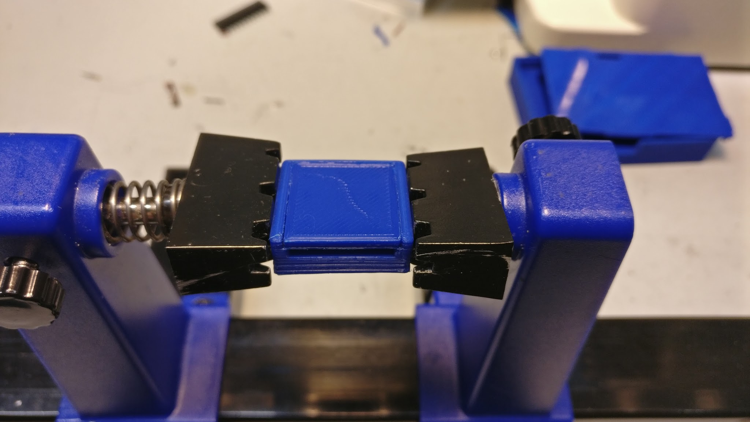

Figure 8. One of the final designs of the IMU case.

The MCU enclosure was produced in much the same way although the first design iterations were not scaled accurately due to not having the actual PCB when designing them. It too featured rounded edges, a lid held in place by friction and holes for all the necessary cables, although alterations made to the design to accommodate the antenna caused the holes not to wholly line up with the board. All these designs were printed in blue PLA on an Ultimaker 2

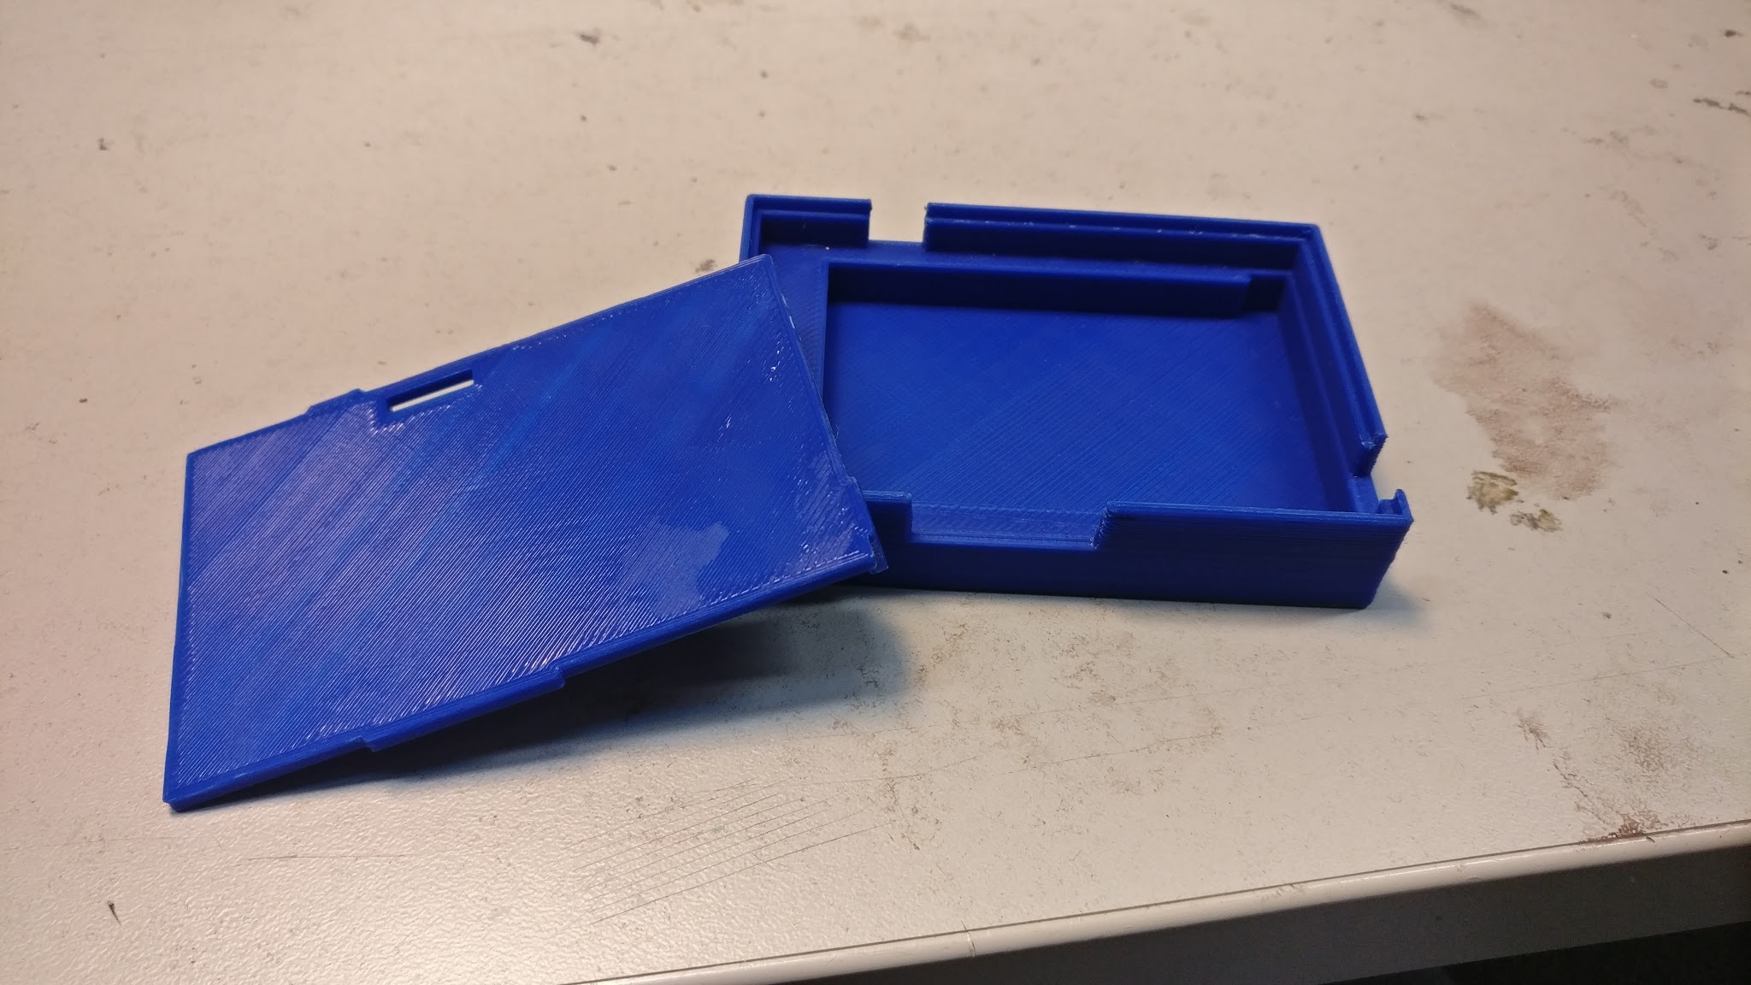

Figure 9. Later version of the MCU case.

# The glove

* 1. Explanation

Originally it was intended that in addition to the jacket, there would be gloves that would further track the wearers movements. These gloves would track finger position using cloth based flex sensors and would track the hand’s movement in relation to the arms with more IMUs.

In the end, it was decided that there was not enough time to properly implement the gloves and as such they were dropped from the project.

* 1. Design

The first iteration of the gloves used individual cloth based flex sensors, comprising of two pieces of neoprene with conductive thread running through them and a piece of EeonTex Conductive Fabric sandwiched between the two pieces that were then sewn together. Each finger of the glove was to have two flex sensors that would be attached by hot glue. The flex sensors themselves were not very accurate in this iteration as to fit two on each finger they had to be very short, thus allowing them to only bend very little. As it also turned out that hot gluing the flex sensors on destroyed them and thus a new design had to be created.

The second iteration of the design used a single large piece of neoprene that all the conductive fabric was attached to and that then formed the top half of a glove that was sown specifically for the project. This design also only used singular very long flex sensors allowing for more reliability in the results. This design also meant though that the glove could only give very rough estimates of the position of the fingers, only being to tell if it was opened or closed and not more specific positions.

It was then intended that this would be connected to its own microcontroller that would interpret the values of the flex sensors and an IMU and then send them forward to the MCU as a i2c slave device. None of this of course came to fruition as it was at this point that we decided to cut the glove for time.

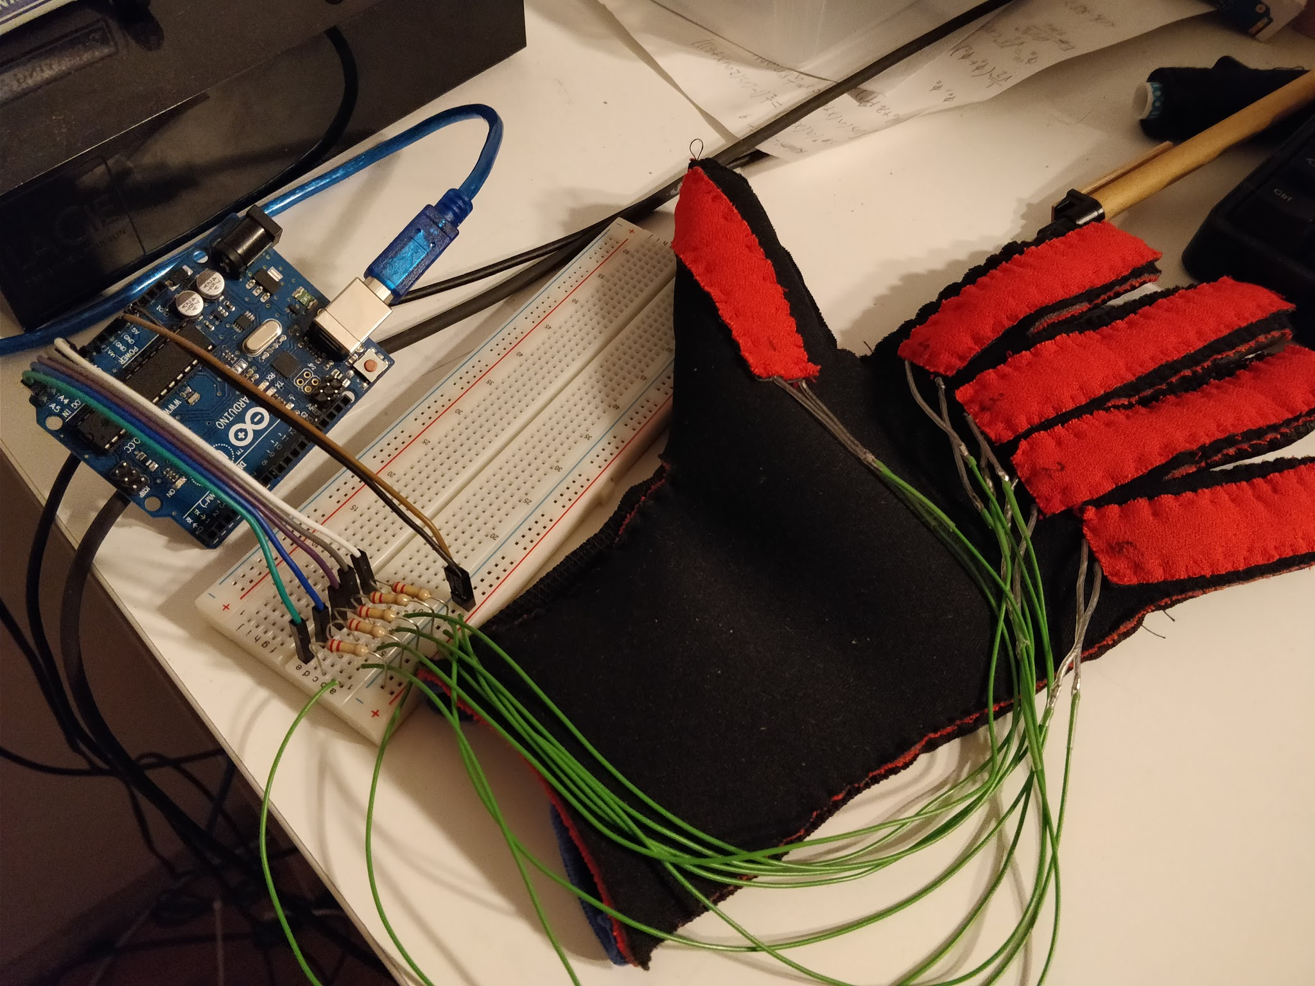

Figure 10. Glove prototype

# The website

# The design for the website was taken from HTML5UP. A website, which offers free to use (under the Creative Commons license) website templates. The website uses their Stellar-template, to which text, and photos and graphics have been added and modified.

The creation of the website didn’t take that long, and was maybe the only part of the project, which was done per schedule. The website is in the domain [protopaja.aalto.fi/futuricec/](http://protopaja.aalto.fi/futuricec/). It offers a detailed view of the project and what the end-result looks like.

Many groups went with the same Stellar-template, and the goal was to make our site stand out a little bit more. The background of the website is a photo taken from the internet, which is scaled to the whole website, per the user’s screen size. This gave the site a little bit more personality and style as well. There are also little details that have been put in the website, for example the customized shirt logo and favicon icon.

# The components

Here is a list of all the components we ordered during the course:

|  |  |  |  |
| --- | --- | --- | --- |
| Part: | Unit price (€): | Quantity: | Quantity used in the final prototype: |
| SparkFun MPU-9250 BreakOut Board (IMU) | 16.63 | 7 | 5 |
| Conductive Thread Bobbin - 12m | 4.39 | 1 | 1 |
| EeonTex Conductive Stretchable Fabric | 27.75 | 1 | - |
| SparkFun ESP32 Thing | 22.19 | 1 | - |
| NEOPRENE MIX P100 | 6.00 | 30 cm | 1 |
| MIKROELEKTRONIKA LI-POLYMER BATTERY 3.7V 2000MAH | 17.27 | 1 | 1 |
| ESPRESSIF ESP-WROOM-32 | 6.05 | 3 | 1 |
| NEPPI 7MM 12/KRT H100 | 2.90 | - | 36 |
| AEROBIC M100 | 15.90 | - | 1 |
| KOVIKE joustava kudottu M100 | 5.90 | - | 1 |
| TARRA 50mm, karkea M100 | 3.50 | - | 1 |
| TARRA 50mm, pehmeä M100 | 3.50 | - | 1 |
| 09.03201.02 - Slide Switch | 1.10 | 3 | 1 |
| CP2102-GM - USB Interface | 2.48 | 3 | 1 |
| CSD16406Q3 - MOSFET | 1.51 | 6 | 2 |
| TMCMA0J107MTRF - Surface Mount Tantalum Capacitor | 0.532 | 3 | 1 |
| 10033526-N3212MLF - USB Connector | 0.561 | 7 | 1 |
| ASMT-YTC7-0AA02 - LED, RGB | 0.777 | 3 | 1 |
| XC6210B332PR - Fixed LDO | 1.07 | 3 | 1 |
| S2B-PH-K-S (LF)(SN) - Wire-To-Board Connector | 0.086 | 15 | 1 |
| PHR-2 - Wire-To-Board Connector | 0.034 | 15 | 1 |
| SPH-002T-P0.5L - Contact | 0.0266 | 15 | 2 |
| BQ29733DSER | 0.591 | 3 | 1 |
| MCP73831T-2ATI/OT | 0.537 | 3 | 1 |
| PBSS4120T,215 | 0.367 | 6 | 2 |
| MCL-S270GC - LED | 0.135 | 6 | 1 |
| MCL-S270SRC - LED | 0.196 | 6 | 1 |
| SD0805S040S0R1 | 0.279 | 6 | 1 |

Table 2. Purchased parts

We ordered and used a lot of components during the course, but we didn’t use all of them in the final prototype. We tested around with the conducting thread and deemed it useless for our application, because how it acted in the clothing. Despite this, we did use nearly all the components ordered for the PCB in the project.

The components we have chosen here, seem to work fine with our application and they do their job flawlessly. Even if we could start over and order new components, we probably wouldn’t (at least with the PCB). Of course, different sizes could be ordered to make the final PCB smaller, but the functions of the components work for us.

The switches and ports on the board feel sturdy enough to last for a while and the battery circuit functions too without any hiccups. The mini USB port is more durable than a micro USB port and the ESP32 WROOM module has the same processor as the ESP32 thing, the microcontroller we did our testing with.

# Reflection of the Project

## Reaching objective

We did reach our minimum objective for the prototype set by ourselves. The original objective was to get a wireless connection (using WiFi) from a smart clothing to a server, and move an arm remotely on a computer screen.

Our vision was to create a full-fledged motion-capture suit, with integrated IMUs and gloves to go with it. In our original budget plan, we planned to order around 20 IMUs for different applications, but we ended up ordering 7.

For the majority of the project, we didn’t have any finished ‘parts’. Everything was in one way or the other unfinished and connecting all the parts together was done at the very end. For example, we had the server and WiFi running individually but the connection between them was not up until the second last week of the project. If we could’ve gotten the connection working earlier, we could had developed the clothing even further. But for reasons explained in part 14.2. we simply didn’t have the time.

In the end, if we’d have to give ourselves an initial objective now, we wouldn’t change our first choice at all. The objective we chose at the beginning was totally reasonable, and accomplishable with the team at hand.

## Schedule

The schedule, in short, didn’t work at all. Our detailed schedule, that the group made in the beginning of the summer didn’t work at all. All our designs and steps of the project should’ve been finished two to 5 weeks earlier than when they were.

There were a lot of factors at play, why the schedule didn’t hold up. We had problems with the group, and people were focusing on wrong things a big part of the time. Our group consisted of 6 people in the beginning and got reduced to three by the end of the course. A big part of the workload got pushed to the end and deadlines started to creep up on us. With limited personnel and people on-board, the stress started piling on us.

A month before the prototype was due, the project manager was changed, and it was at this point, when the original schedule was forgotten completely. Afterwards we started to focus on, what could be accomplished during the remaining time, and could the minimum objective of the project still be accomplished. To our eyes (or the remaining people onboard) the minimum requirement for the project was still reachable. So, we prioritized the tasks most important and got to work on them.

So, the original schedule didn’t hold up, but with our group at the time, it was deemed to fail anyway. We made the best of the situation and came up with a timetable that was in fact truly reachable.

## Risk analysis

Many of the risks that we added to the project plan did happen. For instance, in the original project plan we concluded that the risk of one participant would get sick or leave the course was small (and the effects would be small), however half of the original group, including the project manager left the course. This left us (Bruce, Jere and Elliot) confused, where the project should head now, and even if we’d be able to complete the prototype itself.

A another big risk which realized itself was also the schedule. The schedule as stated in section 14.2. didn’t hold up at all. This introduced a lot of problems regarding the completion of the project, and the remaining group had to adapt to the new situation as best we could.

The group didn’t even have all the required skills, in order to finish the project in the beginning. However everyone of us learned something new, and we were able to overcome our problems, which allowed us to finish the project with dignity.

## Nearing the end

The group had a lot of difficulties with a lot of things, but we managed to come together and accomplish something, that many had their doubts about. Our company’s representative questioned, if we could finish the project, and to be honest so did we. The deadlines we had, one month before the project was due, induced a lot of stress on all of us throughout the course of the 4 last weeks.

This team may have not been the most effective team from the very beginning, but it made up for it in full by the end. We spent time working on the project everyday, even extending to the night. We put a lot of thought and soul into this project, and hopefully it shows just how much we tried.

We realize that to many people it might not seem as much, but to us, what we did during this course was something remarkable. And maybe one of the most important things that all of us learned, is that we can accomplish so much, if we stay determined and work as a group.

We pushed on with the project to the very end, we worked until sunrise on the last day to get the best possible presentation we could, with the cards we were dealt. If nothing else, at least we saw what we could do with a months sleep deprivation, 12 hours time and total irritation towards the project, when we worked as a team.

# Discussion and Conclusions

We all learned something new during the course of the project. One thing we’ve come to realize is that, you can’t really say anything about the outcome, before you reach the end. Similarly, you don’t really know everything you will need and learn during a project. Hopefully this section will clarify how much went into studying new things and above all, learning.

Bruce Clayhills:

I learned a lot during the course, as I was in charge of PCB design and choosing the components to be used on the PCB. I have been studying electrical engineering for only 6 months now, and I didn’t have the knowledge at first to do any of this. I didn’t know what KiCad was, and had never constructed a PCB myself before.

However, I spent a lot of time studying how to use KiCad and learning the basics of PCB design and what all the components on a PCB do. I learned about capacitors and what they mean to the stability of a power input for an MCU and I learned how oscillators and other components of a microcontroller function.

I learned to make schematics in KiCad as well as PCBs with the in-built software that the open source program offers. I also had to learn how different components work with each other, like the battery protection circuit chip and the charger. I learned to better go through the datasheets of components and faster locate usable information, that I need, to get the PCB designed and functioning.

I had to go through a lot of datasheets to find the correct components for the project. I found this to be the most time consuming stage, because most of the components I went through, were either the wrong size, had the wrong operating voltage, or something else, that prohibited me from using them in my design.

On top of the PCB design itself, I was also in charge of the website. Now I had never created a website, so I didn’t have any prior experience in this field either when I started. However, I picked it up pretty fast and managed to make an initial website in a day with HTML5 from a template. I also learned about different components and how they work together to create a website. For example a website uses CSS files and Java files to create specific animations and styles for the site. I also studied a little bit of the interaction between all these parts that make up a website.

And when half our group left a month before the project was due, I became the project manager. Now we were facing deadlines and a lot of stress, because we had so much to do. I think I learned valuable time management skills during the project and I learned to prioritize tasks and set realistic objectives for the project, in order to finish it the best way we could.

All in all, I think this project gave a lot of insight on how much I, and we as team can do, if we’re correctly motivated and work together. Maybe now I’m better equipped to take on even bigger challenges in the future.

Jere Pylkkänen:

I was in charge of programming, the server and the IMUs. For the most part the programming wasn’t an issue, since that’s something I’m familiar with, but I’ve never worked with IMUs or servers before, so there was a lot I needed to learn. Early into the course I created a very simple model in Blender to test out with an MPU-6050 IMU. I had very little experience with Blender, so that was also something new, even though eventually we ended up using the Blend4Web torso from last year’s Futuwear group.

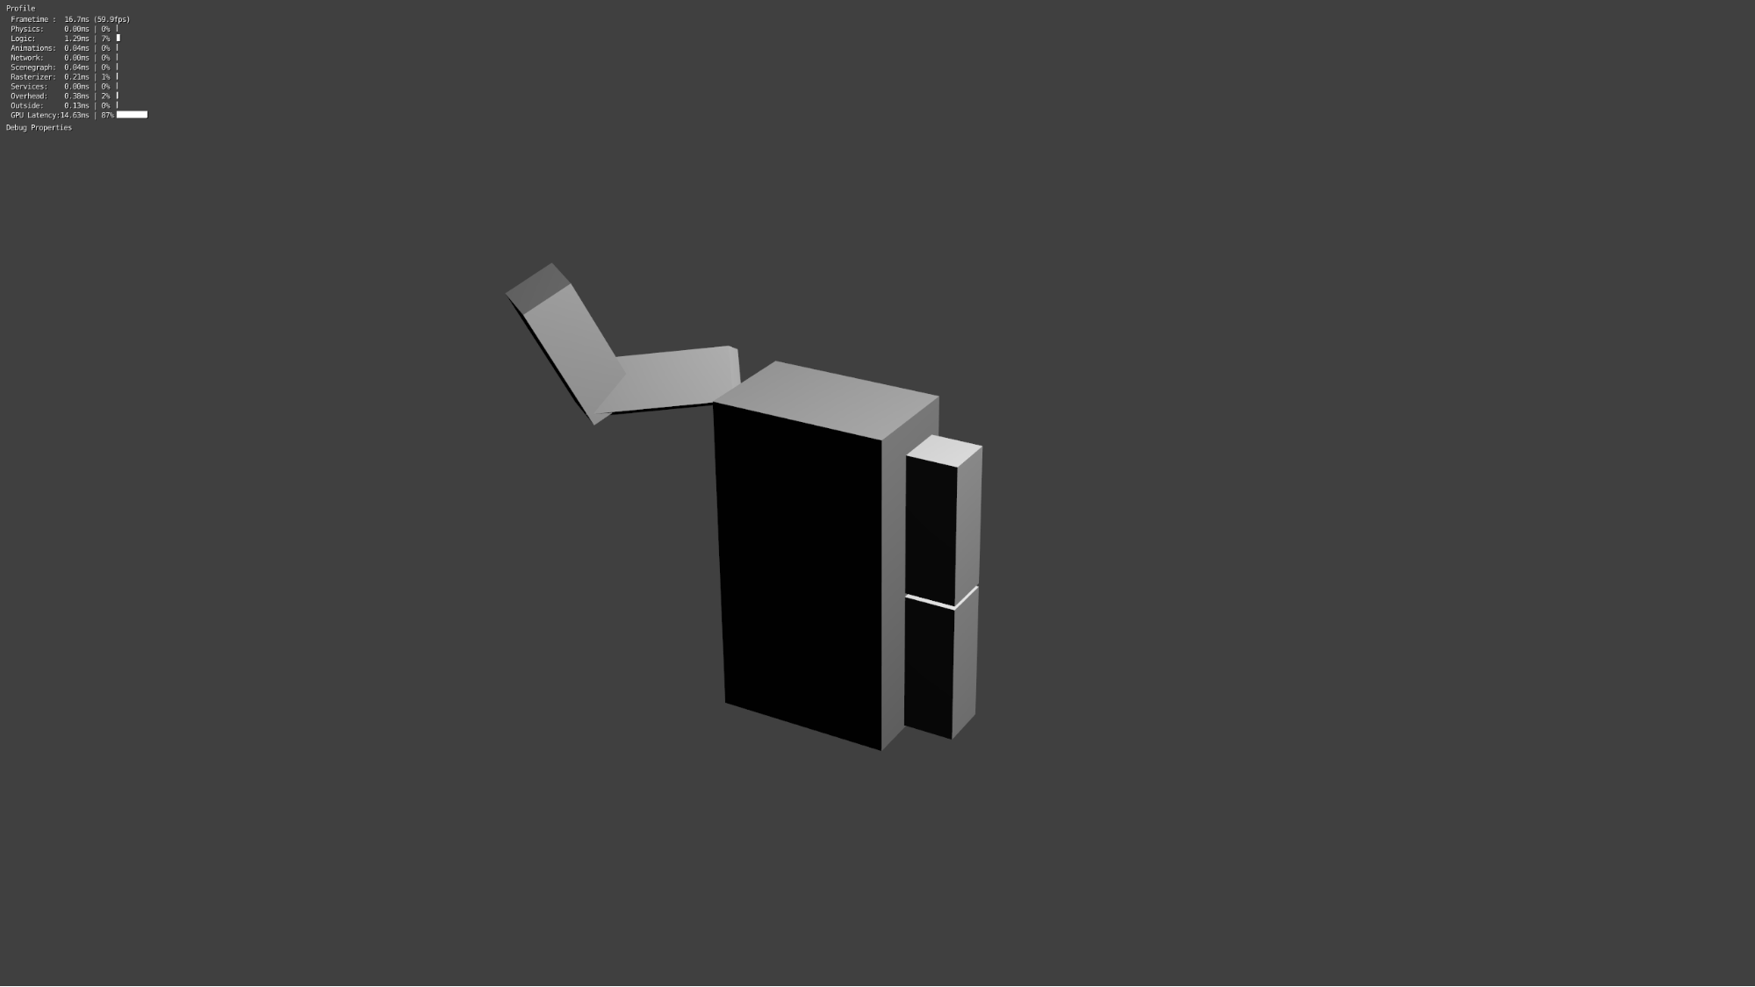

Figure 11. Blender model used early on.

I started working with the server very late into the project, which is unfortunate, because it was something I found really interesting. It was my first time learning JavaScript and getting a web server working, and I think it would’ve been nice to expand the web interface beyond the model of a torso. Alas, the backend took too much time. This is something I’m certainly going to study more after the project, and at least I was able to learn the basics.

Despite all the hardships at the start of the project, I think that the course was overall a good learning experience in many ways. It taught me new technical skills as well as skills related to working as a team. If I was to start working on a similar project today, I would do especially the planning phase differently and emphasise active group communications from the start.

Elliot Kölhi:

The two main things I worked on were the clothes and the 3D printed enclosures. I didn’t really feel that I learned very much in the way of applicable skills from the clothing but I do think it helped me understand the importance of time management. Had I not been so lazy early of in the course I would have had time to realize the failings of the conductive thread based design, and maybe I could have made it work.

In regards to the 3D printed enclosures I learned the basics of using Sketchup which was very helpful and i got much more familiar with the process of 3D printing. Overall I think those skill will be far easier to put into practice and I will definitely be looking into how to use more advanced programs and how to produce more complex 3D printable designs both for personal and educational applications.

I’d also say I learned that I still need to get better at dealing with people I consider to be disagreeable. I thought I’d gotten over my anger management problems but it turns out I just hadn’t encountered anyone that really pushes my buttons in a long time. By the end of the course I had rediscovered and refined a lot of the techniques I once used to deal with my rage.

Conclusion:

The project was a good learning experience for all of us, and even though we didn’t quite accomplish everything we initially wanted to, to us it was still a good course. Many things could’ve and should’ve been done differently, like group communications and time management, but these are all problems, that we could eventually overcome.

Given everything, that has happened, we believe the prototype is the best possible end-result, we could accomplish with the time and group that we had. We put a lot of effort into the project to get it to where it is today, and hopefully you, the reader can see that as well. Thank you for a memorable summer course at Aalto University.

* The team

1. **List of Appendices**

* **Project plan**
* **Schematic**
* **KiCad files**
* **3D-printing files**

All of the above appendices can be found on the project’s [GitHub page](https://github.com/Futuwear-V2/Futuwear-V2).

1. **References**

**[1] - https://www.pjrc.com/store/prop_shield.html**